SAMPLE NEWSLETTER ARTICLE
Customize the following article to include a story in your facility’s newsletter.
Go to IBHRE.org/IBHRE-Day to download the IBHRE Day logo
and other graphics to accompany your story.
______________________
[FACILITY] Joins IBHRE in Celebrating
the Growth of Its Global Footprint
[Facility] has joined the International Board of Heart Rhythm Examiners® in celebrating the growing number of IBHRE-certified specialists worldwide. Since 1985, IBHRE has certified more than 17,000 heart rhythm practitioners who practice in 70 countries around the world. On IBHRE Day, Feb. 9, 2026. IBHRE will celebrate these cardiac specialists and their impact on the field of heart rhythm management.
<Quote From Company Representative>
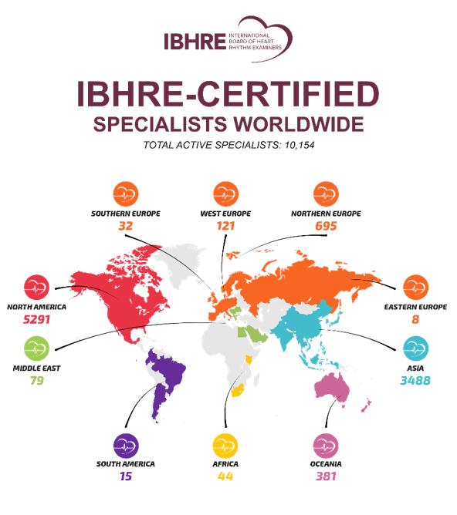
IBHRE is a self-governing global credentialing board that provides competency validation in the fields of cardiac device therapy, cardiac electrophysiology, and cardiac device remote monitoring.
The organization has validated the expertise of cardiac device experts and electrophysiologists in six of the seven continents (excluding Antarctica). Currently, more than 10,000 IBHRE-certified specialists actively practice in their specialty area. As such, IBHRE credentials have come to signify the international gold standard in heart rhythm certification.
In our celebration, [FACILITY] acknowledges the commitment of the following employees who have validated their knowledge by earning an IBHRE credential, and by completing IBHRE’s rigorous continuous learning process to maintain their certified status.
<List IBHRE-Certified Employees>
Practitioners who have earned an IBHRE certification have proven their competency and professional expertise by earning one or more of the following credentials:
- Certified Cardiac Device Specialist (CCDS)
- Certified Electrophysiology Specialist (CEPS)
- Certified Electrophysiology Specialist – Adult (CEPS-A)
- Certified Electrophysiology Specialist – Pediatric (CEPS-P)
- Cardiac Device Remote Monitoring Specialist (CDRMS)
To learn more about IBHRE, visit IBHRE.org.

